BOARD MEETING MINUTES
Monday 6:00 PM
Location of Meeting: Tesfa International School

Call to order: The Vice-Board Chair, Abby Hendricks called to order the meeting at
6:00 PM on September 24, 2018

Board Members/Director Present or Absent:
Name | Present/Absent
Patrick Exner (Board Chair/Community Member) | Absent
Hussein Ahmed (Parent Member) | Absent
Amir Orandi (Board Secretary/Parent Member) | Present
John Groenke (Community Member) | Absent
Antoninette Monster (Board Treasurer/Community Member) | Present
Maren Rodriguez (Teacher Member) | Present
Abby Hendricks (Vice-Chair/Teacher Member) | Present
Jonas Beugen (Director/Ex-officio) | Present
Mohamed Selim (Assistant Director/Ex-Officio) | Present

Guests and Community Members Present:

Name | Position/Role
Joe Aliperto | VOA Authorizer Representative
Susie Meyer | Reading Specialist

Tesfa International School
Mission: Tesfa International School is committed to providing an equitable and empowering education for all. Our scholars will engage in a transdisciplinary curriculum supported by conceptual and inquiry based learning. Side-by-side with dedicated educators, scholars will develop the knowledge, skills, and characteristics necessary for active citizenship throughout the world.
Vision: Our students will be prepared for a successful transition to the most rigorous and challenging middle school programs. Through their experience at Tesfa, students will be held to the highest of standards both academically and socially, to prepare the students for college and careers, as well as with the leadership skills required of active and productive citizens in the 21st century. Through access and equity, students will follow a pathway to success for them and their communities.

- – Call to order – Made by Abby Hendricks at 6:00 PM

- – Roll Call of Attendance – Taken by Mohamed Selim – See above

- – APPROVAL OF AGENDA
Subject | Approval of Agenda
Motion | Motion to approve the agenda.
Made by | Antoninette Monster |  |  |  | Seconded |  | Amir Orandi
Discussion
Vote | None | Yea | 4 | Nay |  | 0 |  | Abstain | 0

- – Board Calendar Dates
- Monday, October 22, 2018 – Regular School Board Meeting at 6:00
- Monday, November 26, 2018 – Regular School Board Meeting at 6:00

- – Comments from Citizens Present
- None

6.0 – EXECUTIVE DIRECTOR REPORT
Subject | Executive Director Report
Discussion | - Calm start to the school year  - Classrooms are calm and focused on learning  - Higher retention helped  - Staff committed  - Buses are our toughest area due to longer routes (continuously monitoring and making improvements)  - Revisiting change of school name during next board meeting  - Exploring a daycare on site – may serve as a kindergarten readiness program

7.0 – PRESENTATIONS AND DISCUSSION
Subject | 7.1 - Presentations and Discussion – School Wide Reading Initiative (Susie Meyer)
Discussion | Ms. Susie Meyer, Reading Specialist, presented on the school wide reading initiative at Tesfa:  - Worked with kids on choosing books at their reading level (e.g., five-finger rule)  - Choosing books that are interesting to them  - Read aloud daily  - Hoping to move to chapter books  - Working stamina of sustained silent reading  - Digging through books and checking out books from library  - Reading Stars – reading log for each month and rewarding students at assembly  - PJs and books – students come to school with PJs and we have DEAR time (Drop Everything and Read)  - Readers and Leaders week – School administrators will visit classes and read to students (other visitors coming to school – signing up kids for library cards, firefighters and police officers coming to read, Erin Murphy and Columbia Heights Mayor visiting Kindergarten)  - November – working on a big reading event and friendly competition between classes  - World map in the office to make connections to books students read  - Poetry contest (poem in my pocket day)  - Book shop – advertising books in the hallway

Subject | 7.2 – Presentation and Discussion - Northstar Accountability System
Discussion | - Tesfa was identified for comprehensive support based on the last three years of performance (identification was based on MCA proficiency, student growth, and continuous attendance)  - Administration was not present during the first 2 years and faced many challenges starting last year  - Met with comprehensive support team to discuss plan. The team is extremely helpful in providing information and will be beneficial moving forward in supporting our work.  - Explanation of new accountability system  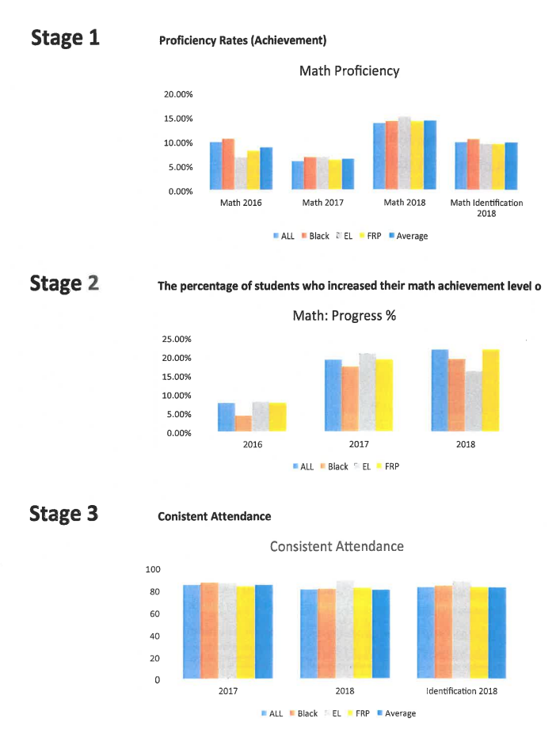

Subject | 7.3 – Presentations and Discussion - Proposed New Lease Parameters
Discussion | 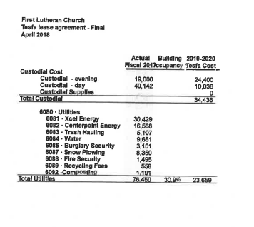  - We’ll not pay more than 90% of lease aid  - Parameters of new lease explained by Jonas Beugen, Executive Director  - Board members that attended finance committee meeting recommend staying at current site with lease parameters set by FLC

8.0 – APPROVAL OF CONSENT AGENDA
Subject | Personnel Recommendations
Motion | Motion to approve the consent agenda
Made by | Maren Rodriguz |  |  |  | Seconded |  | Amir Orandi
Discussion | 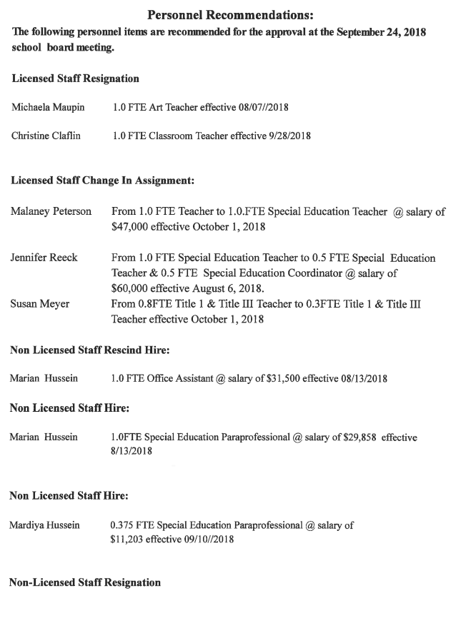
Vote |  | Yea | 4 | Nay |  | 0 |  | Abstain | 0
Decision | Motion passed unanimously.

Subject | Minutes – Regular Meeting Minutes of August 13, 218
Motion | Motion to approve regular meeting minutes of August 13, 2018.
Made by | Antoninette Monster |  |  |  | Seconded |  | Maren Rodriguz
Discussion | None
Vote |  | Yea | 4 | Nay |  | 0 |  | Abstain | 0
Decision | Motion passed unanimously.

9.0 – ACTION ITEMS
Subject | 9.01 – Approval of 725 Records Procurement Procedure  9.02 – Revision of Policy 592
Motion | Motion to approve Policy 725 and revision of Policy 592
Made by | Antoninette Monster |  |  |  | Seconded |  | Maren Rodriguz
Discussion | None
Vote |  | Yea | 4 | Nay |  | 0 |  | Abstain | 0
Decision | Motion passed unanimously.

Subject | 9.03 - Approval of FY 19 budget revision
Motion | Motion to approve FY 19 budget revision
Made by | Antoninette Monster |  |  |  | Seconded |  | Amir Orandi
Discussion | - Jonas Beugen summarized budget cuts and reductions for the FY 19 budget  - Budget will be monitored very tightly
Vote |  | Yea | 4 | Nay |  | 0 |  | Abstain | 0

10.0 – VOA AUTHORIZER INPUT
Subject | None
Discussion

11.0 – CLOSED SESSION
- None

12.0 ADJOURNMENT
Motion | Motion to adjourn the school board meeting at: 8:09
Made by | Maren Rodriguz |  |  |  | Seconded |  | Amir Orandi
Discussion
Vote |  | Yea | 4 | Nay |  | 0 |  | Abstain | 0
Decision | Motion passed unanimously.

