BOARD MEETING MINUTES-
Monday 6:00 PM
Location of Meeting: Tesfa International School

Call to order: The Board Chair, Patrick Exner, called to order the meeting at
6:12 PM on August 13, 2018 .

Board Members/Director Present or Absent:
Name | Present/Absent
Patrick Exner (Board Chair/Community Member) | Present
Hussein Ahmed (Parent Member) | Present
Amir Orandi (Parent Member) | Present
John Groenke (Community Member) | Present
Antoninette Monster (Community Member) | Present
Maren Rodriguez (Teacher Member) | Present
Abby Hendricks (Teacher Member) | Present
Jonas Beugen (Director/Ex-officio) | Present
Mohamed Selim (Assistant Director/Ex-Officio) | Present

Guests and Community Members Present:
Name | Position/Role
Joe Aliperto | Business Office
James Cosgrove | Paraprofessional

Tesfa International School
Mission: Tesfa International School is committed to providing an equitable and empowering education for all. Our scholars will engage in a transdisciplinary curriculum supported by conceptual and inquiry based learning. Side-by-side with dedicated educators, scholars will develop the knowledge, skills, and characteristics necessary for active citizenship throughout the world.
Vision: Our students will be prepared for a successful transition to the most rigorous and challenging middle school programs. Through their experience at Tesfa, students will be held to the highest of standards both academically and socially, to prepare the students for college and careers, as well as with the leadership skills required of active and productive citizens in the 21st century. Through access and equity, students will follow a pathway to success for them and their communities.

Subject | Swearing in of new board members
Discussion | The following board members are officially sworn in: Amir Orandi (parent), John Groenke (community), Antoinette Monster (community), Maren Rodriguez (teacher), Hussein Ahmed (parent), and Abby Hendricks (teacher).

Subject | Nomination of board chair
Motion | Patrick Exner nominated to be board chair.
Made by | Amir Orandi |  |  |  | Seconded |  | Abby Hendricks
Discussion | None
Vote |  | Yea | 7 | Nay |  | 0 |  | Abstain | 0

Subject | Nominations of varies board roles
Motion | Motion to approve Abby Hendricks as vice-chair, Antoinette Monster as treasurer, and Amir Orandi as board secretary.
Made by | John Groenke |  |  |  | Seconded |  | Hussein Ahmed
Discussion | Patrick Exner explained the varies roles needed to be filled by school board members (board secretary, treasurer, and vice-chair).
Vote |  | Yea | 7 | Nay |  | 0 |  | Abstain | 0

AGENDA and MINUTES
Subject | Approval of Agendas
Motion | Motion to approve the agenda.
Made by | Patrick Exner |  |  |  | Seconded |  | Antoinette Monster
Discussion | None
Vote |  | Yea | 7 | Nay |  | 0 |  | Abstain | 0
Decision | Motion passed unanimously.

Subject | Accept the June 4, 2018 Minutes
Motion | Move to accept minutes from June 4, 2018.
Made by | Patrick Exner |  |  |  | Seconded |  | Amir Orandi
Discussion | None
Vote |  | Yea | 7 | Nay |  | 0 |  | Abstain | 0
Decision | Motion passed unanimously.

Subject | Declaration of Conflicts
Discussion | Jonas Beugen shared the requirement by VOA to include a “Declaration of Conflicts” at the beginning of board meeting.

Subject | Appointment of the Identified Official with Authority (IoWA)
Motion | Motion to approve Jonas Beugen as the Identified Official with Authority (IoWA).
Made by | Patrick Exner |  |  |  | Seconded |  | Hussein Ahmed
Discussion | The Minnesota Department of Education (MDE) requires that school districts, charter schools or other organizations annually designate an Identified Official with Authority to comply with State Access Control Security Standard 1.0 which states that all user access rights to Minnesota state systems must be reviewed and recertified at least annually. The Identified Official with Authority will assign job duties and authorize external user’s access to MDE secure systems for their local education agency (LEA) or organization. The school board authorizes Jonas Beugen to act as the Identified Official with Authority for Tesfa International School.
Vote |  | Yea | 7 | Nay |  | 0 |  | Abstain | 0

FINANCIAL REPORT
Subject | Financial Report
Motion | Motion to accept financial report.
Made by | Antoinette Monster |  |  |  | Seconded |  | Amir Orandi
Discussion | 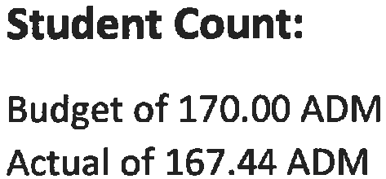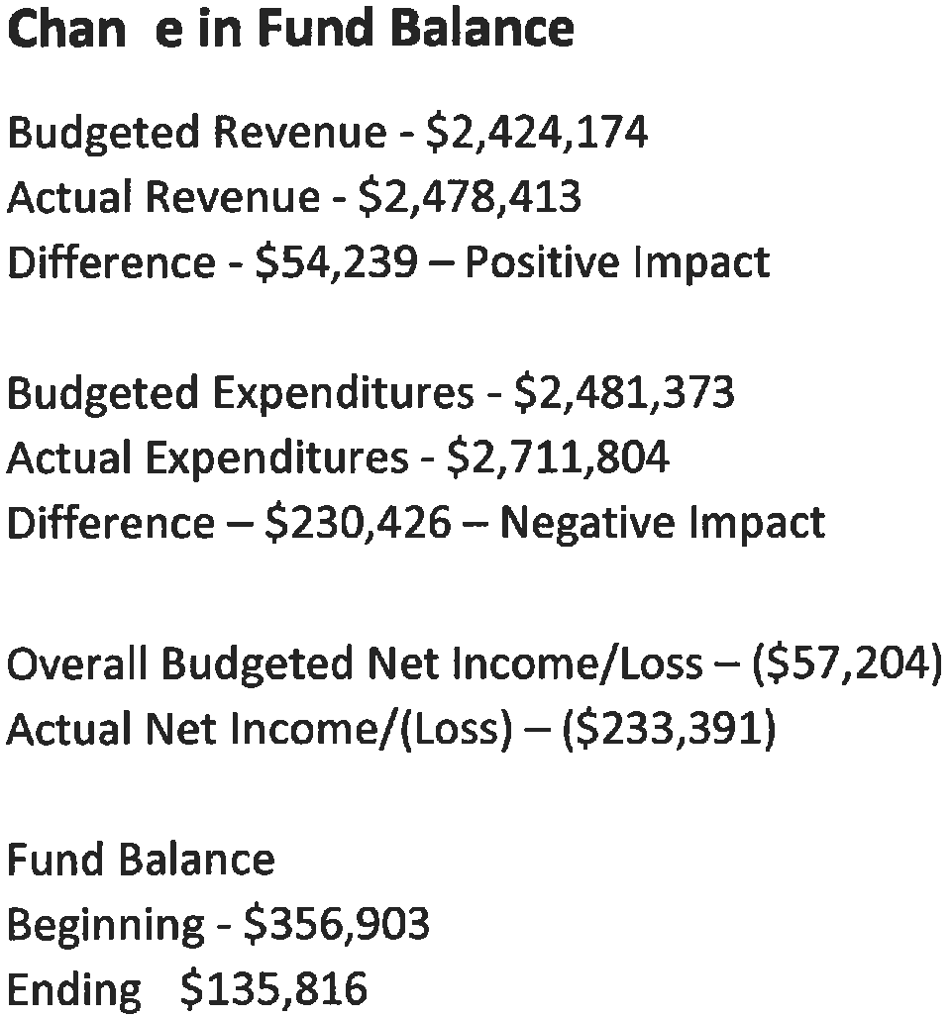  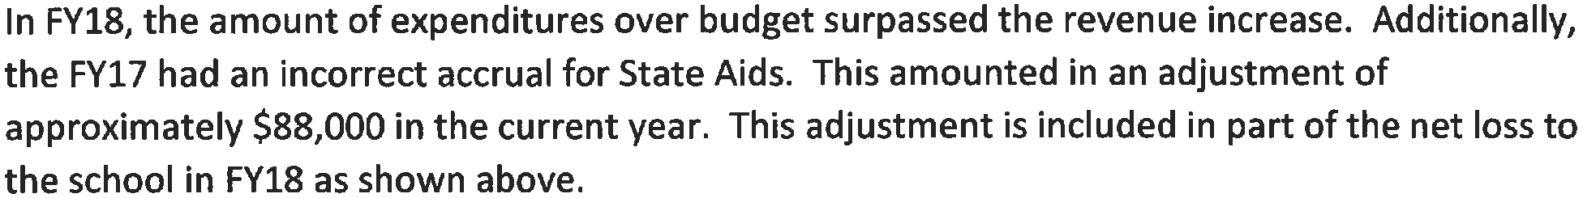
Vote |  | Yea | 7 | Nay |  | 0 |  | Abstain | 0
Decision | Motion passed unanimously.

Subject | Enrollment Update
Motion | Motion to accept enrollment update.
Made by | Abby Hendricks |  |  |  | Seconded |  | Hussein Ahmed
Discussion
Vote |  | Yea | 7 | Nay |  | 0 |  | Abstain | 0
Decision | Motion passed unanimously.

Subject | Personnel Recommendations
Motion | Motion to accept personnel recommendations.
Made by | Antoinette Monster |  |  |  | Seconded |  | John Groenke
Discussion | 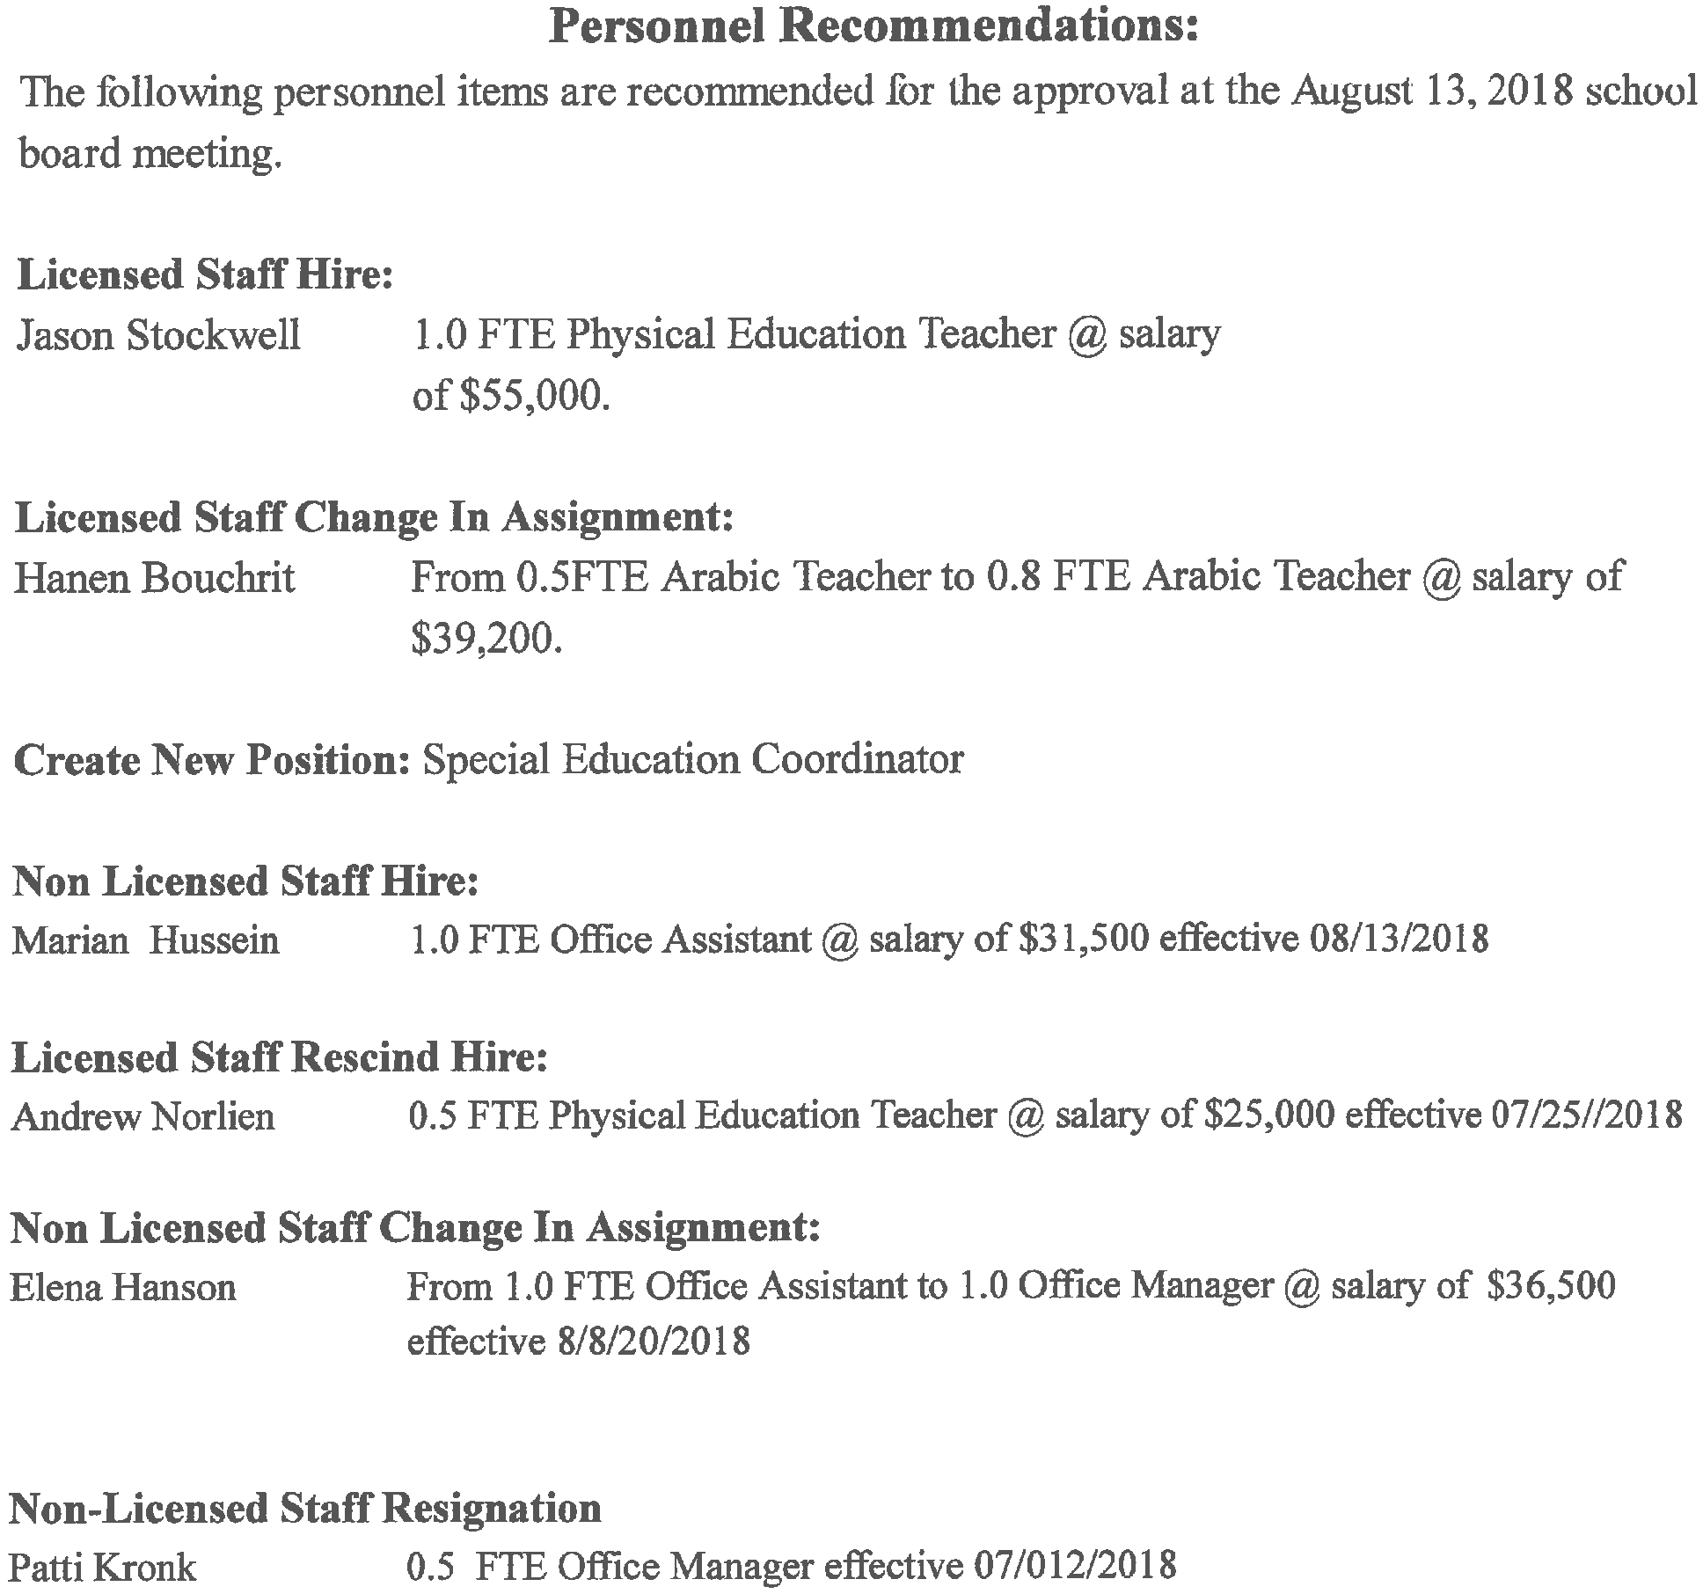
Vote |  | Yea | 7 | Nay |  | 0 |  | Abstain | 0
Decision | Motion passed unanimously.

DIRECTOR UPDATE
Subject | Director Update – Jonas Beugen and Mohamed Selim
Discussion | None

NEW BUSINESS
Subject | 2019 Lease
Discussion | - Review budget with Joe  - Explore moving with families  - Jonas Beugen and Joe will meet with landlord to negotiate lease at new site  - Consider approximate budget of moving to new site

Subject | School Board Meeting Calendar
Motion | Motion to approve a board meeting calendar for the fourth Monday of each month at 6:00 beginning of September.
Made by | Amir Orandi |  |  |  | Seconded |  | Abby Hendricks
Discussion
Vote |  | Yea | 7 | Nay |  | 0 |  | Abstain | 0
Decision

Subject | 2018-2019 School Calendar Revision
Motion | Motion to approve September 14, 2018 as staff development day.
Made by | Antoinette Monster |  |  |  | Seconded |  | Amir Orandi
Discussion | The staff development day for training on the math curriculum (Investigations).
Vote |  | Yea | 7 | Nay |  | 0 |  | Abstain | 0
Decision

Subject | Academic Goals
Motion | Motion to accept academic goals as presented.
Made by | John Groenke |  |  |  | Seconded |  | Amir Orandi
Discussion | 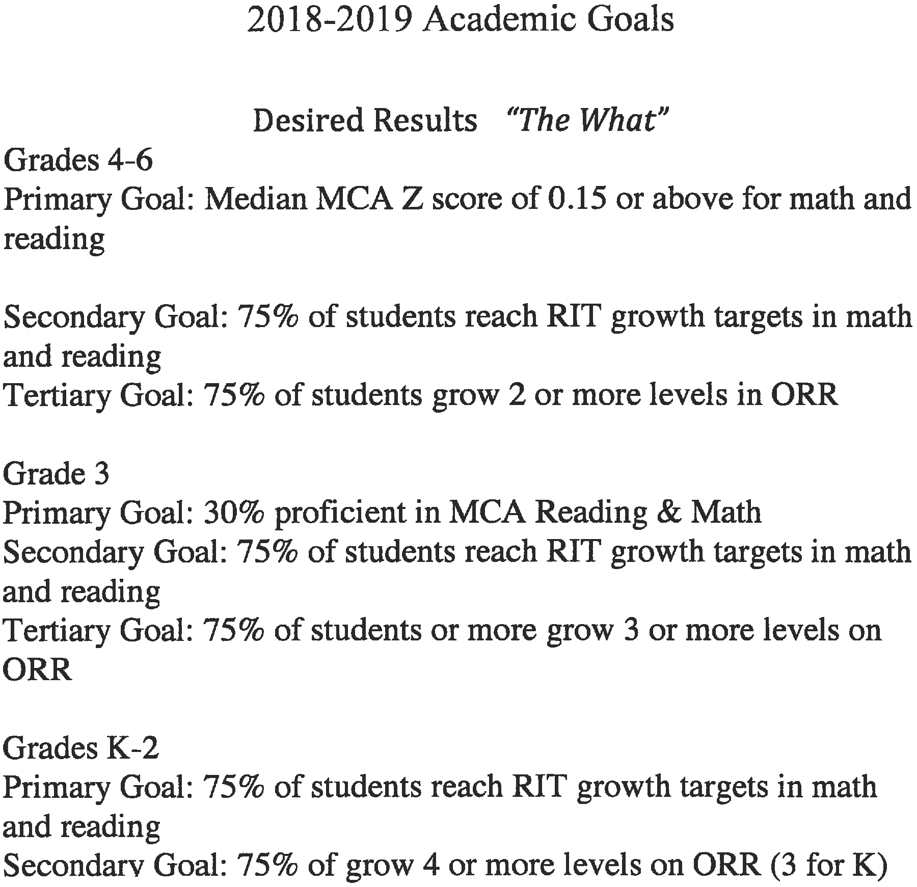
Vote |  | Yea | 7 | Nay |  | 0 |  | Abstain | 0
Decision

Subject | Employee Handbook
Motion | Motion to accept employee handbook.
Made by | Antoinette Monster |  |  |  | Seconded |  | Abby Hendricks
Discussion
Vote |  | Yea | 7 | Nay |  | 0 |  | Abstain | 0
Decision | Motion passed unanimously.

Subject | Family Handbook
Motion | Motion to approve family handbook.
Made by | John Groenke |  |  |  | Seconded |  | Hussein Ahmed
Discussion
Vote |  | Yea | 7 | Nay |  | 0 |  | Abstain | 0
Decision | Motion passed unanimously.

Subject
Discussion

AUTHORIZER INPUT
Subject | None
Discussion

POLICY UPDATES
Subject | Revision of Early Entrance (590)
Motion | Motion to approve revision with changes.
Made by | Abby Hendricks |  |  |  | Seconded |  | Amir Orandi
Discussion | A.1. change date to September 15th  Change B.1 to “The parent agrees it’s in best interest.”
Vote |  | Yea | 7 | Nay |  | 0 |  | Abstain | 0
Decision | Motion passed unanimously.

PUBLIC COMMENTS
Subject | James Cosgrove
Discussion | James Cosgrove complimented the board on a productive and positive meeting.

ADJOURNMENT
Motion | Motion to adjourn the school board meeting at: 8:09
Made by | Antoinette Monster |  |  |  | Seconded |  | John Groenke
Discussion
Vote |  | Yea | 7 | Nay |  | 0 |  | Abstain | 0
Decision | Motion passed unanimously.

NOTES:
Maren left meeting at 6:58 returned at 7:00
Joe left meeting at 7:08.

